Lecture 26



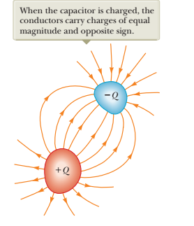

Such a combination of two conductors is called a capacitor. The conductors are called *plates*

Charges +Q and -Q : a potential difference exists

Experiment: the charge is linearly proportional to the potential difference $Q \sim ∆V$

$Q=C∙ ∆V$

C is called *capacitance*

the SI unit of capacitance: Faraday

1F = 1C/1V

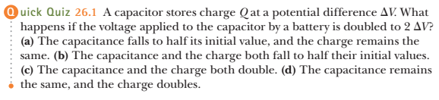



capacitance of the sphere with radius a

The quantity of charge is proportional of the potential of the sphere

imagine the second conductor: concentric sphere of infinite radius and -Q charge

the electric potential of the sphere is kQ/a

Hence, the capacitance of the sphere:

Q / ( kQ/a) = a/k = 4πε0a

it depends only on geometric characteristics of the capacitor



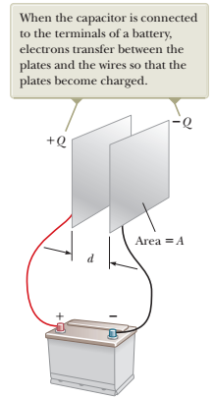 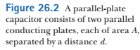

Two parallel, metallic plates of equal area *A* are separated by a distance *d* as shown in Figure 26.2

Charges Q and -Q

The surface charge density: σ=Q/A



The electric field between plates is uniform

The potential difference is equal to:

Hence, the capacitance is equal to:

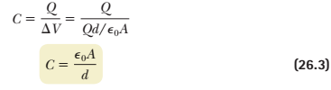

the capacitance of a parallel-plate capacitor is proportional to the area of its plates and inversely proportional to the plate separation

If A increases two times:

If d decreases two times:

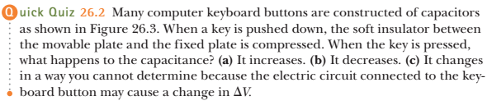

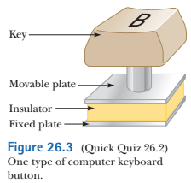

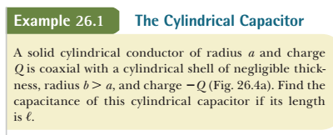

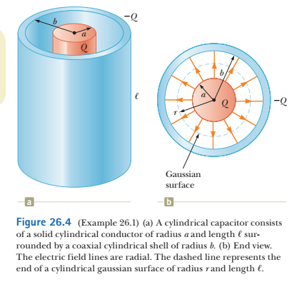

Potential differences between two points is equal to:



Electric field of a charged wires with charge density λ is:

E = 2k\*λ/r ( Gauss’s Law)

Hence:



Capacitance C is Q/ΔV:





A spherical capacitor consists of a spherical conducting shell of radius *b* and charge -*Q* concentric with a smaller conducting sphere of radius *a* and charge *Q* (Fig. 26.5, page 782). Find the capacitance of this device.

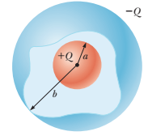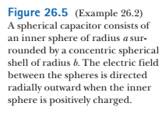

We can determine a magnitude of the electric field between spheres using Gauss’s Law

Electric field E is radial and its magnitude is E= kQ/r2

How to find the capacitance?

1. The potential difference is:







the capacitance is equal Q/ΔV:



If we move the outer sphere to infinity:



It is a capacitance of a spherical conductor